NAME :- SATYAM KUMAR JHA

STUDENT ID:- 2122630050

SECTION :- K1

C ASSIGNMENT

Q1 . Write a C program to take n values from user and then print the sun and average of these numbers using array.

ANS-

#**include**<stdio.h>

**int** main()

{

**float** a[100], sum=0, avg;

**int** i, n;

printf("Enter n: ");

scanf("%d", &n);

printf("Enter numbers:\n");

**for**(i=0; i< n; i++)

{

printf("a[%d] = ", i);

scanf("%f", &a[i]);

}

**for**(i=0; i< n; i++)

{

sum = sum + a[i];

}

avg = sum/n;

printf("Sum is %f\n", sum);

printf("Average is %f", avg);

**return** 0;

}

Output is

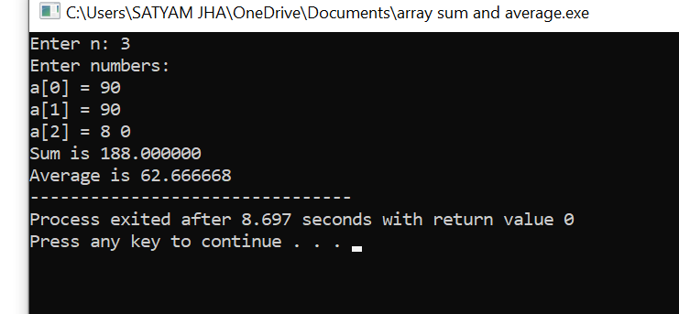

Q2 Write a C program to find the biggest number among n numbers using an array.

ANS:-

#include <stdio.h>

int main()

{

int size, i, largest;

printf("\n Enter the size of the array: ");

scanf("%d", &size);

int array[size];

printf("\n Enter %d elements of the array: \n", size);

for (i = 0; i < size; i++)

{

scanf("%d", &array[i]);

}

largest = array[0];

for (i = 1; i < size; i++)

{

if (largest < array[i])

largest = array[i];

}

printf("\n largest element present in the given array is : %d", largest);

return 0;

}

0utput is:-

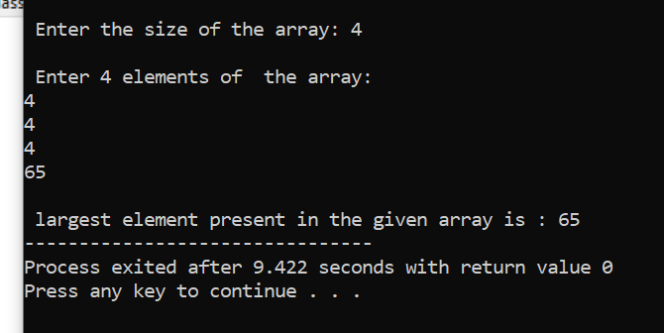

Q3- Write a C program to find the mean of n numbers using an array.

Then display the numbers which are less than the mean value and separately display the numbers which are greater than mean value.

ANS:-